1. Create one Jenkins job using the below code and create three stages.

stage1: Git clone to download the source code.
Source Code: https://github.com/betawins/VProfile-1.git
Prerequisites:
- Jenkins installed and running
- Git installed: git --version
- Jenkins Git plugin installed
- GitHub repository accessible

Steps:
- Jenkins → New Item → Pipeline
- Enter job name: VProfile
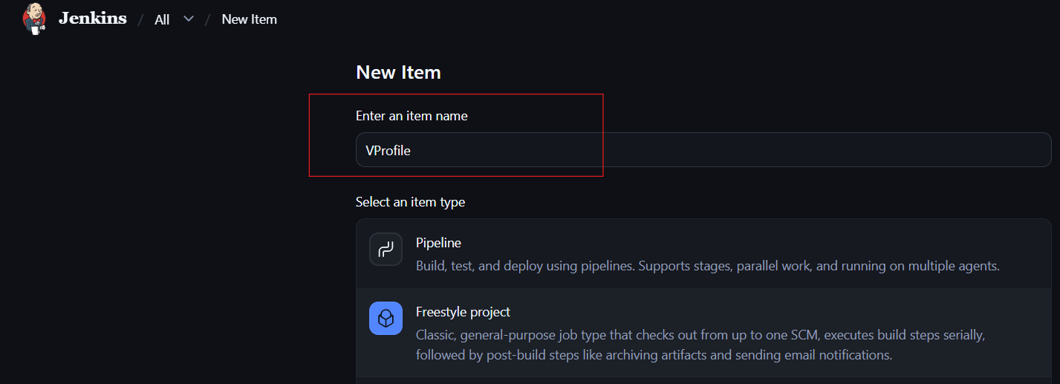
- Go to General - discription
- Source Code Management
Click on Git:
Repository URL: 'https://github.com/betawins/VProfile-1.git'
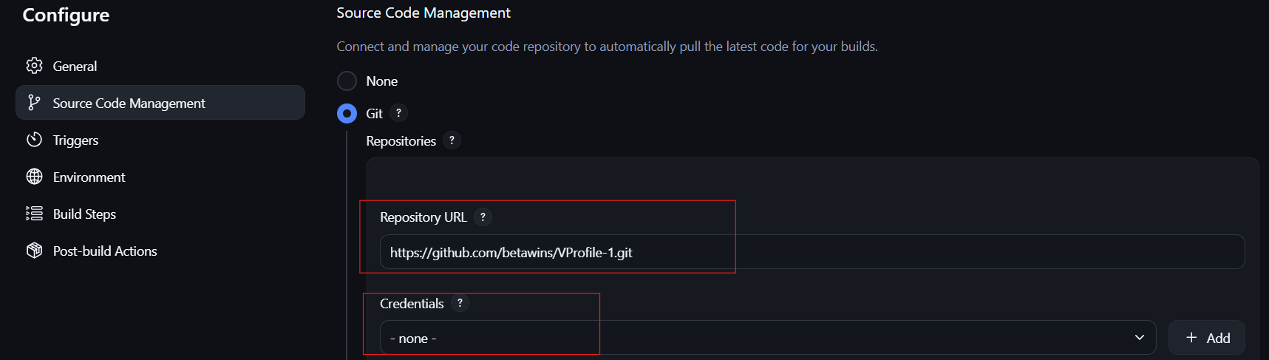

- Branch Specifier (blank for 'any') 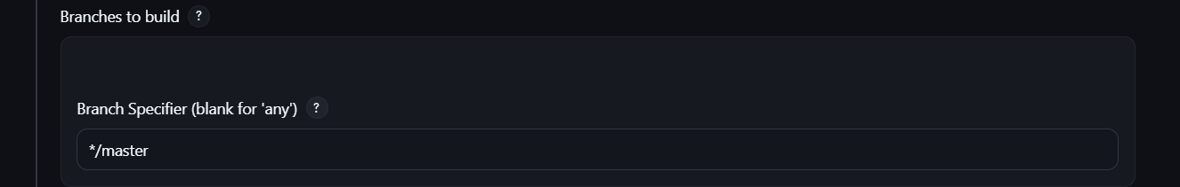
- Click Build Now 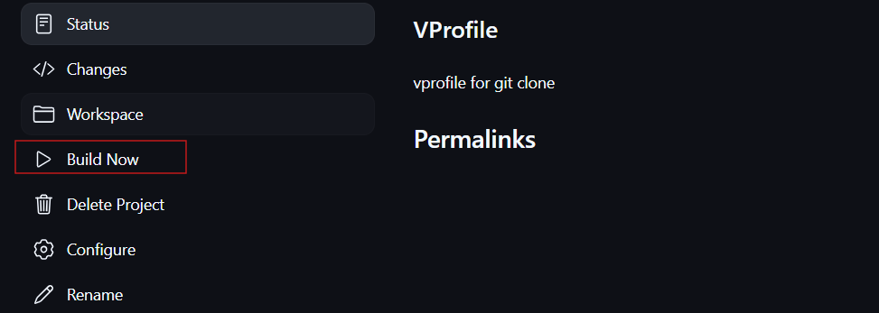
- Check Console Output
- Verify Finished: SUCCESS
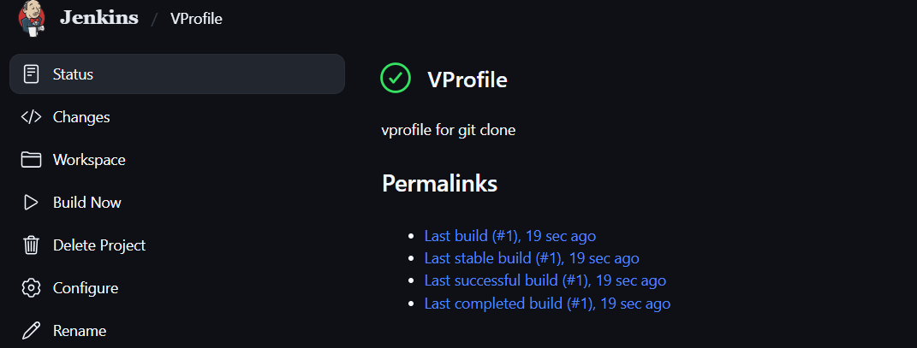
- Source code will be available in the Jenkins workspace.
- Go to Jenkins servers check
Run- cd /var/lib/Jenkins/workspace / v-profile
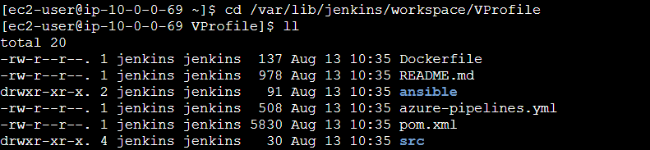

Stage2: SonarQube Integration to check the quality of code.
SonarQube Prerequisite
- EC2 instance with Java installed
- use t3 large with atleast 20gb memory to run sonarqube
- MySQL database server or MySQL RDS instance

SonarQube Integration
- Launch EC2 for SonarQube.
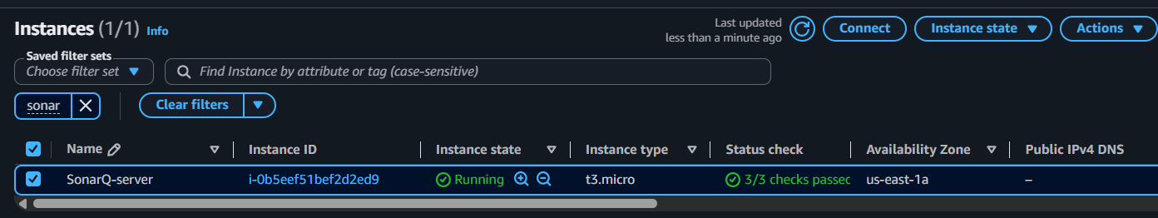
Connect to terminal
sudo su -
- Install Java 21
dnf install java-21-amazon-corretto -y
java –version
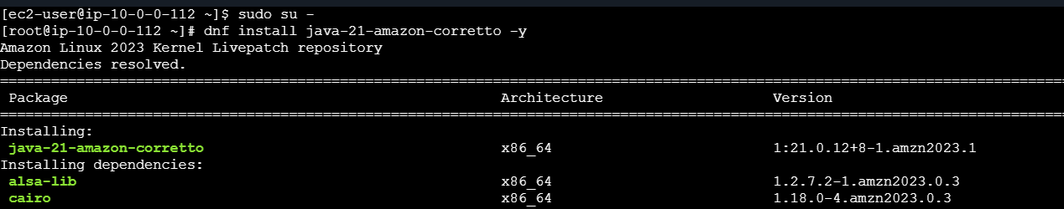
- Download and extract SonarQube
wget <SONARQUBE-URL>
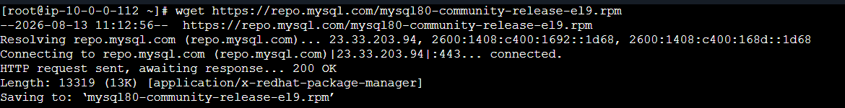
Key gen
rpm --import https://repo.mysql.com/RPM-GPG-KEY-mysql-2022

- Install mySQL
sudo yum install mysql-community-server -y 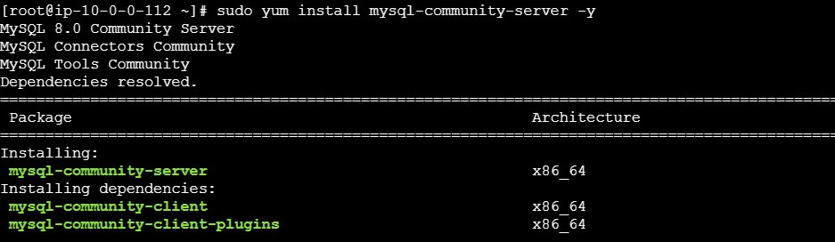

- Start MySQL-port number 3306
systemctl start mysqld
systemctl status mysqld
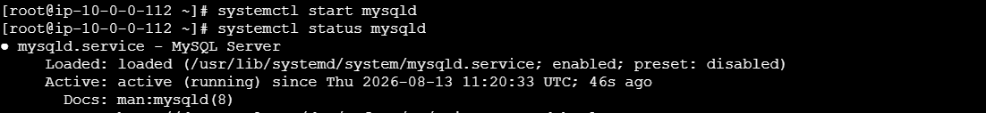
- Get temporary password
grep "temporary password" /var/log/mysqld.log
- Login to MySQL
mysql -u root -p
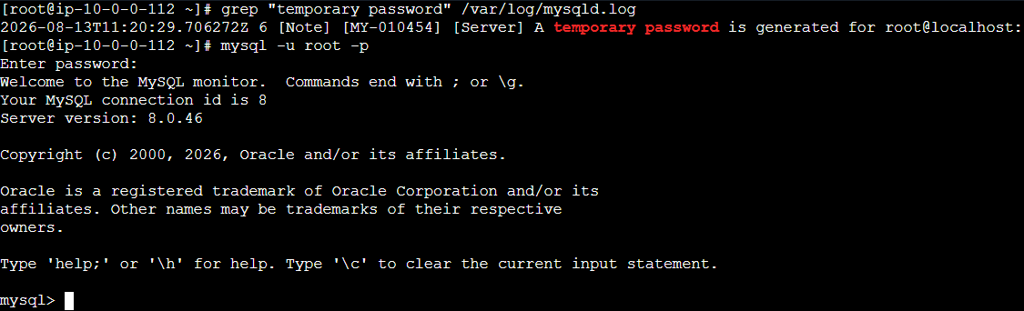

- Change root password
ALTER USER 'root'@'localhost' IDENTIFIED BY 'Admin@123';
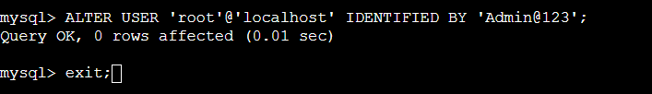
11.Install SonarQube
cd /opt # Go to /opt directory

wget https://binaries.sonarsource.com/Distribution/sonarqube/sonarqube-26.7.0.124771.zip # Download SonarQube
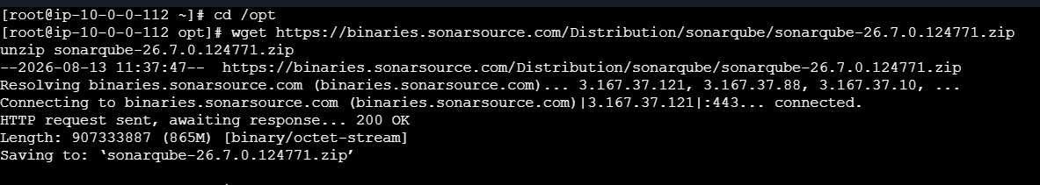
unzip sonarqube-26.7.0.124771.zip # Extract SonarQube package
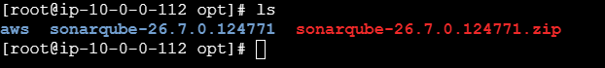
mv sonarqube-26.7.0.124771 sonarqube # Rename SonarQube folder 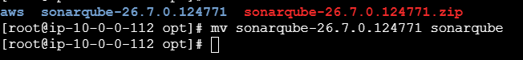

Login to MySQL
mysql -u root -p
12. Create SonarQube Database
CREATE DATABASE sonar CHARACTER SET utf8 COLLATE utf8_general_ci;
SHOW DATABASES;
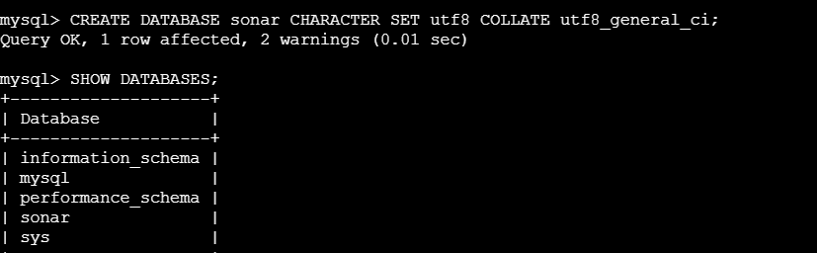

13.Create users in my sql
- local user : CREATE USER 'sonar'@'localhost' IDENTIFIED BY 'sonar@123';
- remote user : CREATE USER 'sonar'@'%' IDENTIFIED BY 'sonar@123';
- Grant permissions
  - GRANT ALL ON sonar.* TO 'sonar'@'localhost';
  - GRANT ALL ON sonar.* TO 'sonar'@'%';
- Check user
  - SELECT user, host FROM mysql.user;
- Apply privileges
  - FLUSH PRIVILEGES;
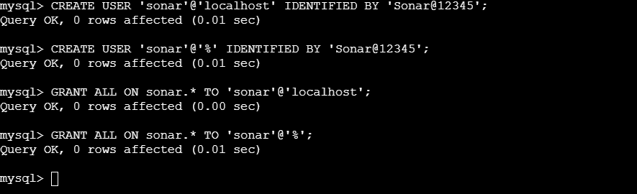
- Exit MySQL
exit;
- Go to SonarQube directory
cd /opt/sonarqube
ls
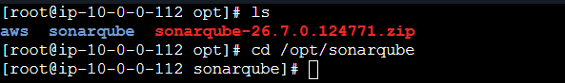
- Go to conf
cd conf/
ls
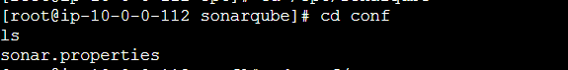
- Edit configuration
vi sonar.properties
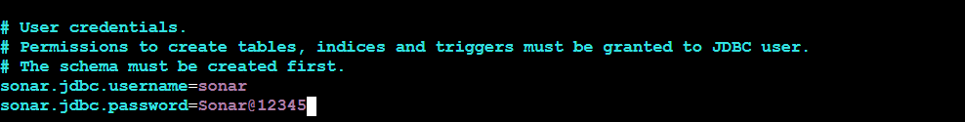
Uncomment/update these:
sonar.jdbc.url=jdbc:mysql://localhost:3306/sonar

sonar.web.host=0.0.0.0
sonar.web.context=/sonar
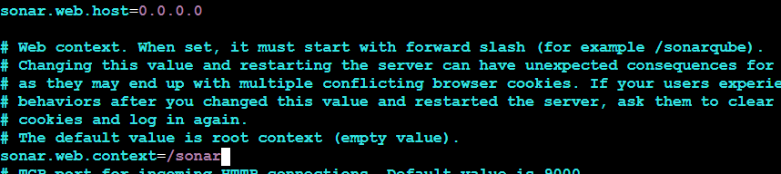

Start SonarQube :
Note: The sonar user does not exist. Create it first.
sudo su –
useradd sonar
chown -R sonar:sonar /opt/sonarqube
Exit root: exit
- Switch to sonar user: su - sonar
- Go to SonarQube: cd /opt/sonarqube/bin/linux-x86-64/
- Start: ./sonar.sh start
- Check: ./sonar.sh status
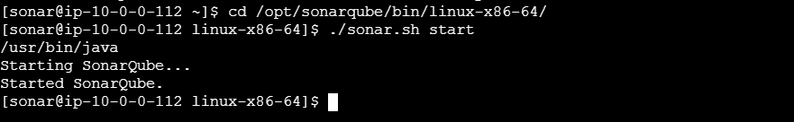

Integrate SonarQube with Jenkins

1. Install SonarQube Plugin
Jenkins → Manage Jenkins → Plugins → Available plugins
Search: SonarQube Scanner
Install it.
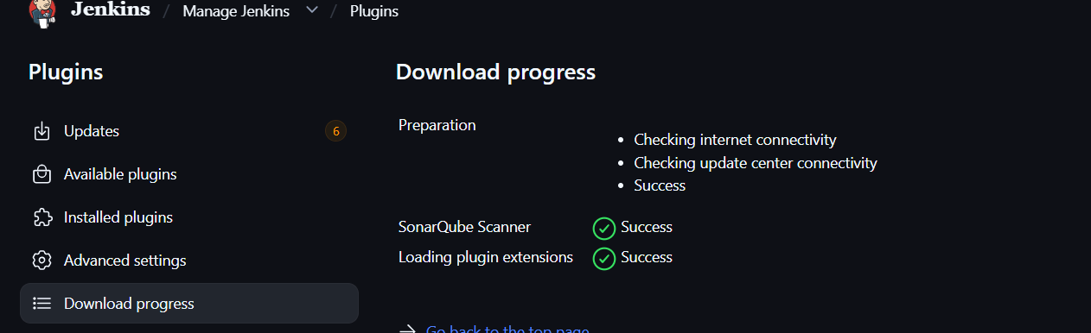

2. Configure SonarQube Server
Manage Jenkins → System → SonarQube servers → Add SonarQube
Name: SonarQ Server
Server URL: http://<SonarQube-IP>:9000/sonar
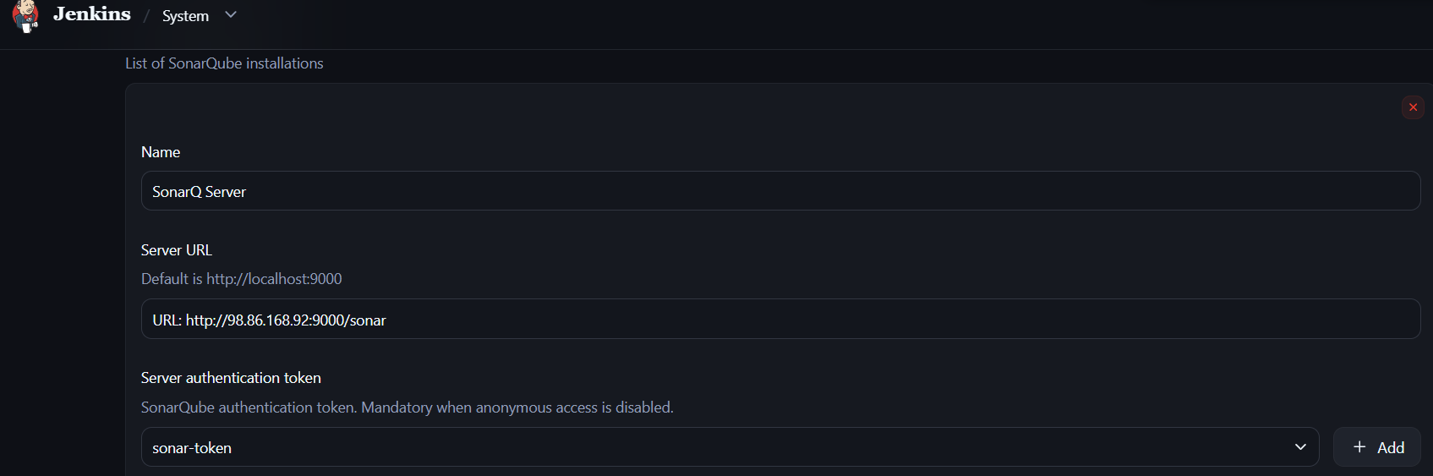
Credentials: SonarQube Token
Select : Secrete text

3. Generate SonarQube Token
SonarQube → My Account → Security → Generate Token
Copy the token.
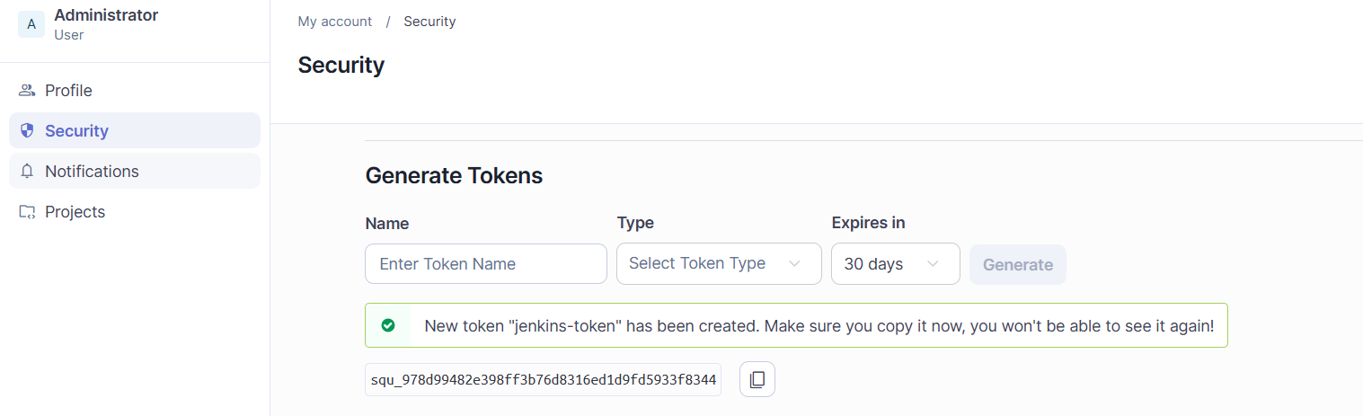

4. Add Token to Jenkins
Manage Jenkins → Credentials → System → Global credentials → Add Credentials
Kind: Secret text
Secret: <SonarQube-token>
ID: sonar-token
Save.
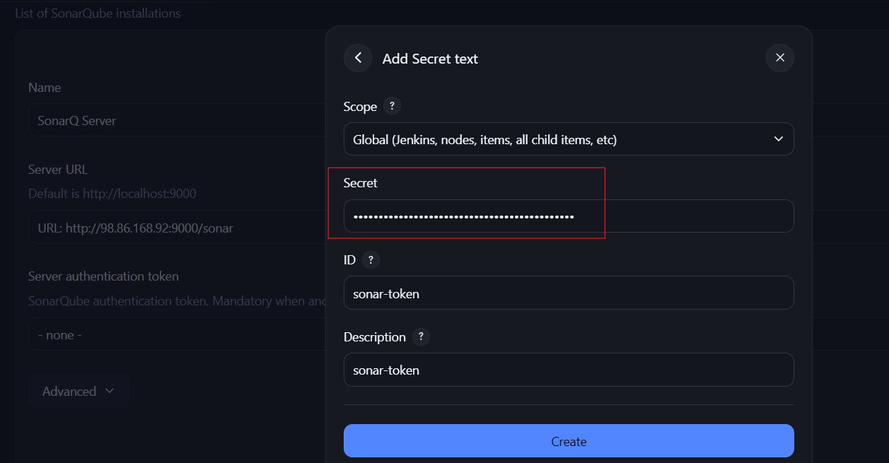

5. Install Sonar Scanner
On Jenkins server:
cd /opt
wget <Sonar-Scanner-URL>
unzip <sonar-scanner.zip>
mv <sonar-scanner-folder> sonar-scanner
Configure:
vi /opt/sonar-scanner/conf/sonar-scanner.properties
Add:
sonar.host.url=http://<SonarQube-IP>:9000/sonar

6. Configure Scanner in Jenkins
Manage Jenkins → Tools → SonarQube Scanner → Add
Name: Sonar-Scanner
SONAR_RUNNER_HOME: /opt/sonar-scanner
Save.
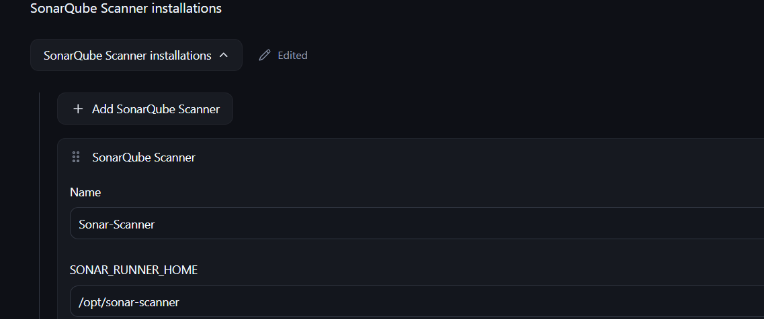

7. Add SonarQube to Job
Job → Configure → Build Steps → Execute SonarQube Scanner
Got to VProfile -> configureBuild environmentBuid steps-execute sonar

Select the SonarQube server/token if the job configuration provides the option.
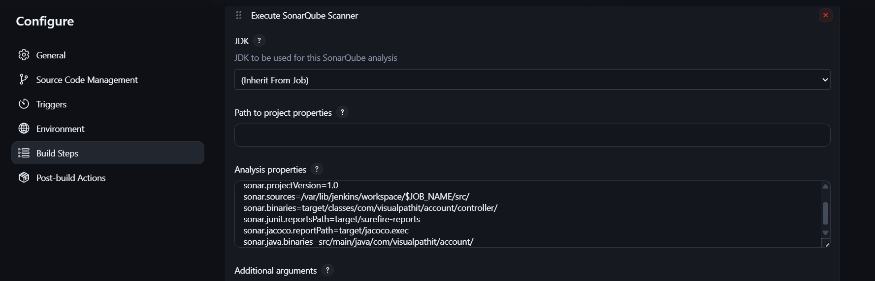

Save → Build Now

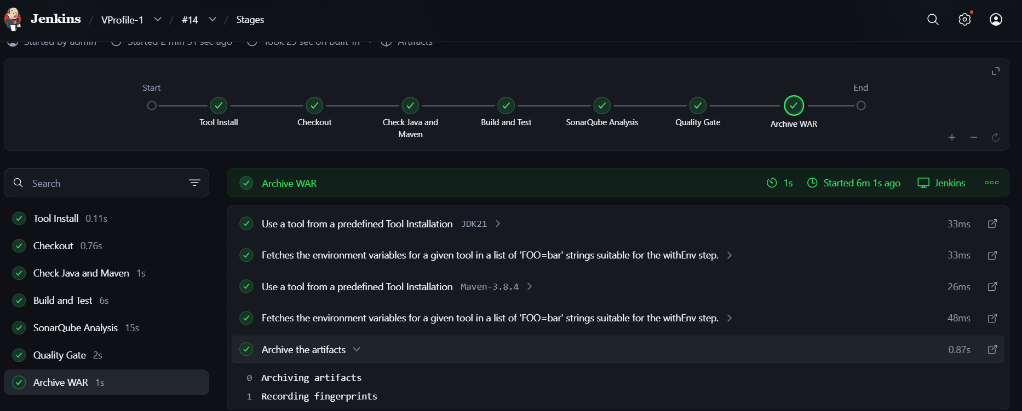

Test in sonarqube
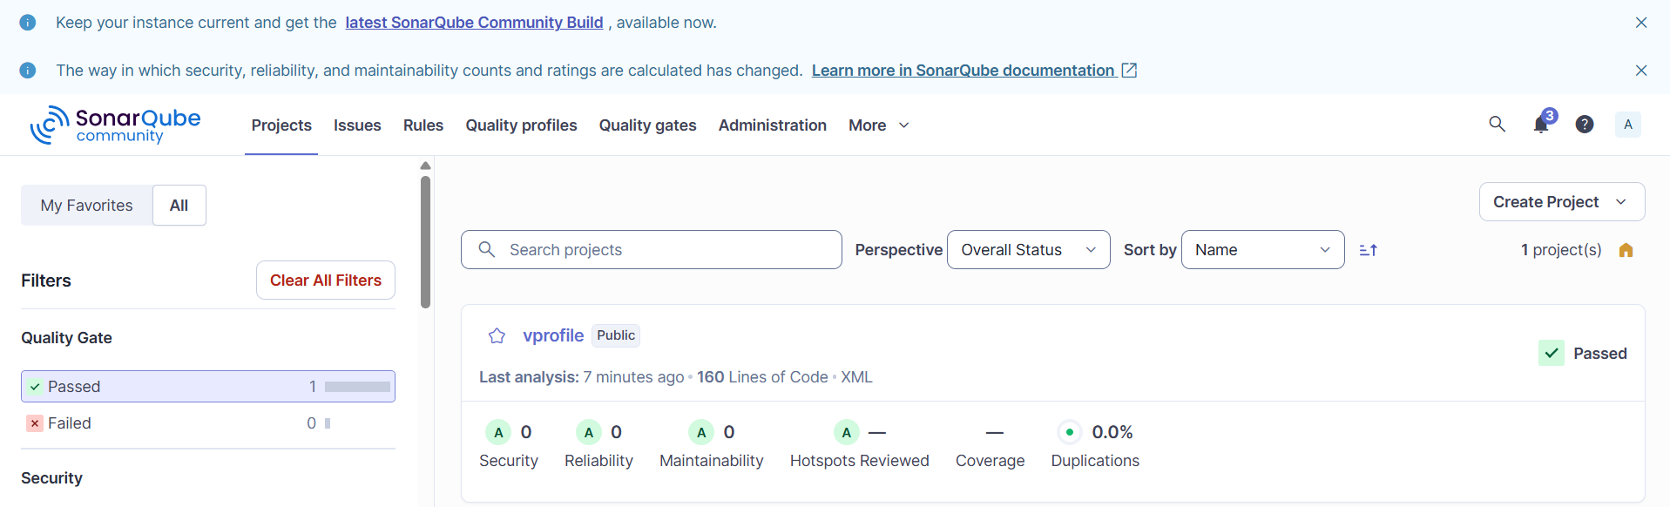

Stage3: Slack Integration to send the alerts to slack.
Purpose: Send Jenkins build alerts/notifications to Slack.
- Jenkins → Manage Jenkins → Plugins
- Install Slack Notification Plugin
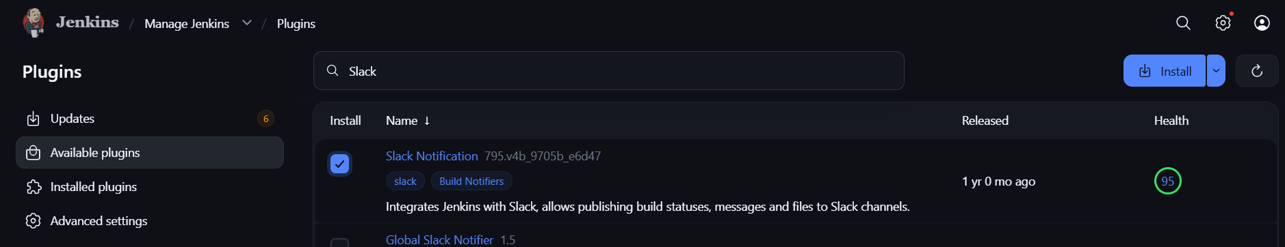

- Create Slack channel → #jenkins-alerts
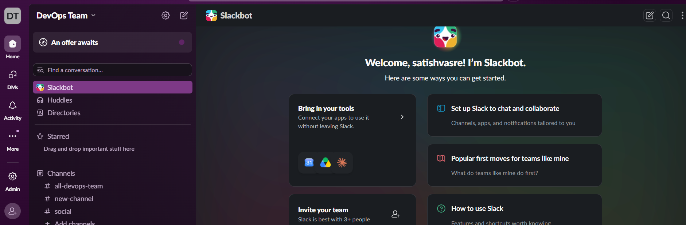
- Jenkins → Manage Jenkins → System → Slack
- Configure Slack workspace, credentials/token and channel.
Create slack Credential
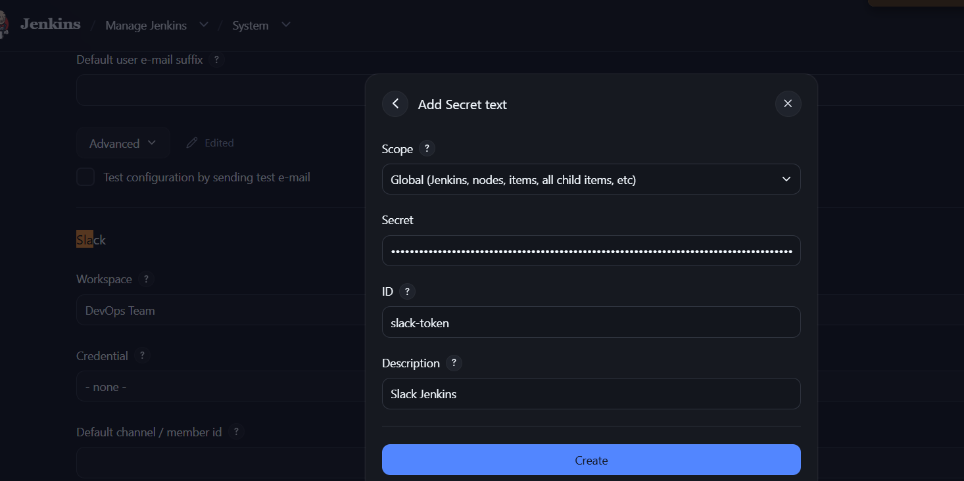
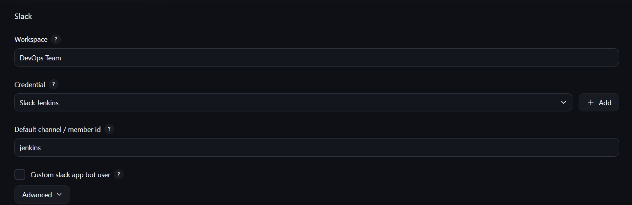
- In Jenkins job → Configure → Post-build Actions → Slack Notifications

- VProfile-1 → Configure → Pipeline → Script
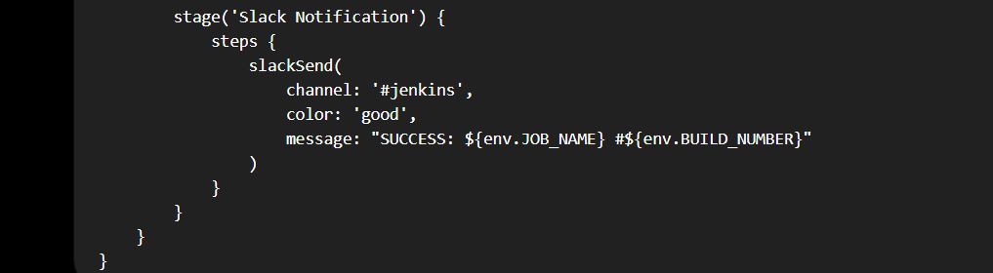
Add the Slack stage to your existing Jenkinsfile.

- Save → Build Now → Check Slack channel
Flow:
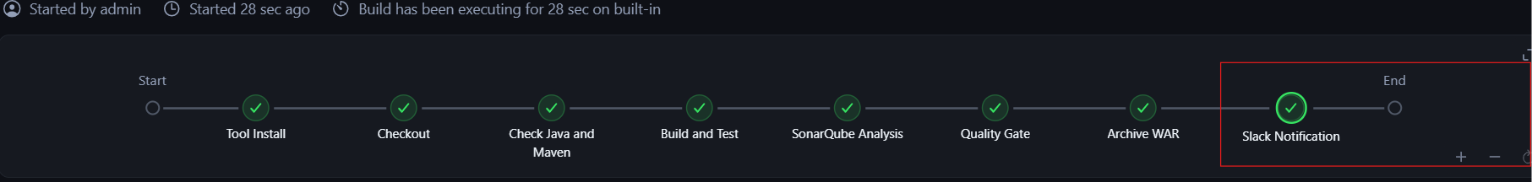
Jenkins → Build → Success/Failure → Slack Alert
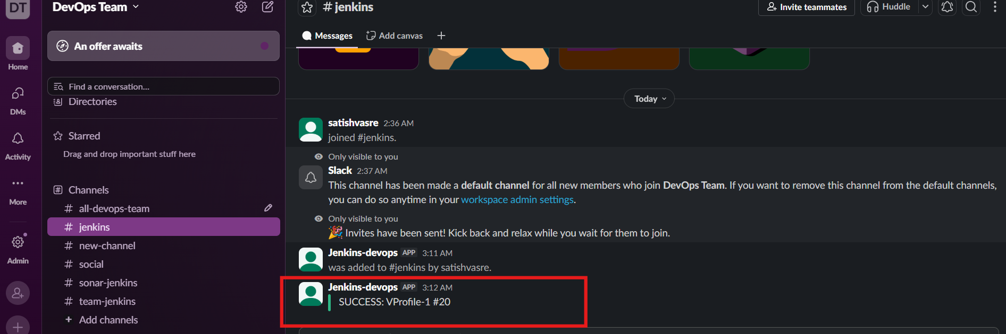

2. Create one Jenkins job using the below code and create three stages.

stage1: Git clone to download the source code.
Prerequisites:
- Launch Ec2
- Jenkins installed and running
- Git installed: git --version
- Jenkins Git plugin installed
- GitHub repository accessible

Stage 1: Git Clone
- Jenkins → New Item
- Select Freestyle project
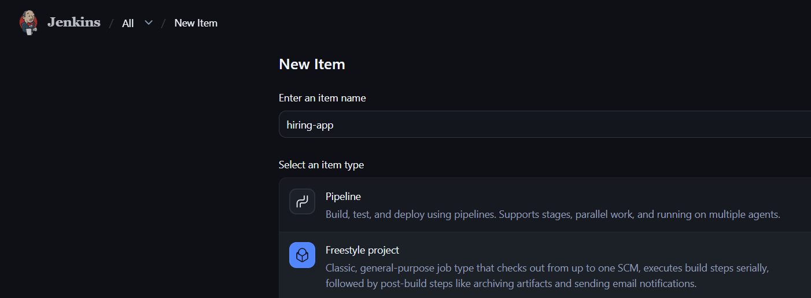
- Go to Source Code Management
- Select Git
- Repository URL:
https://github.com/betawins/hiring-app.git
- Branch:
*/main

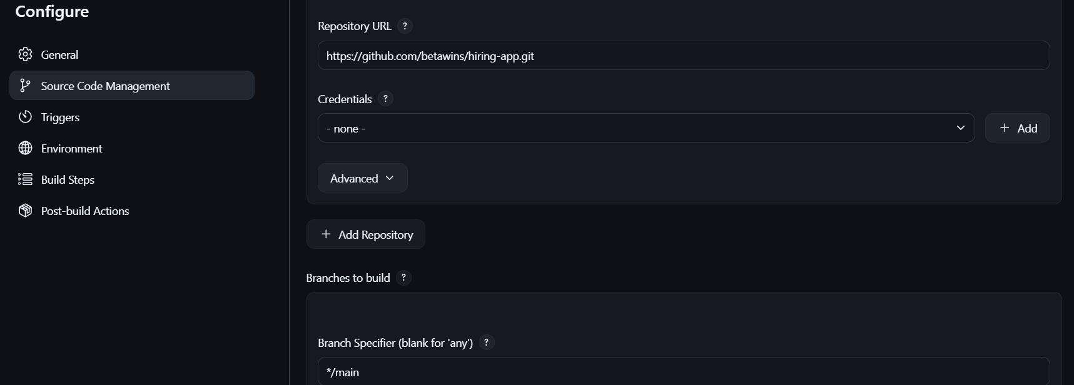
- Click Save
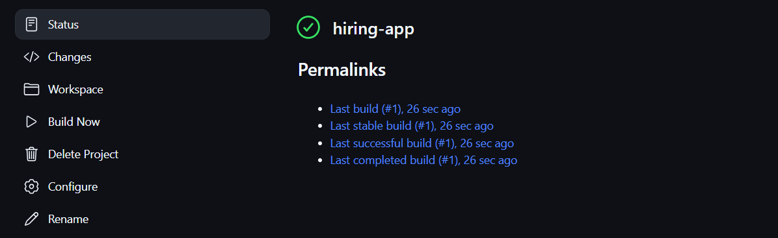
Jenkins will automatically clone the GitHub repository into the workspace when the job runs.

Stage2: Sonarqube Integration to check the quality of code.

Source Code: https://github.com/betawins/hiring-app.git

SonarQube EC2
Needs:
- Java
- SonarQube
- Port 9000 reachable from Jenkins
- SonarQube token

Errors and fixes
# | Error / Issue | Fix
1 | unzip: cannot find or open sonarqube-*.zip | SonarQube ZIP was not downloaded
2 | mv: cannot stat 'sonarqube-*' | SonarQube directory didn't exist at that location
3 | /opt/sonarqube contained sonarqube-25.12.0.117093 inside it | Corrected directory structure
4 | sonar.sh: command not found | sonar.sh was inside the nested directory
5 | Permission denied when using ls/find | /opt/sonarqube had 700 permissions; used sudo
6 | mv .../*: No such file or directory | Used cp -a to correctly copy the installation files
7 | JAVA_HOME was empty | Java 21 was installed; SonarQube successfully found /usr/bin/java

1. SSH to new SonarQube EC2
ssh -i your-key.pem ec2-user@3.235.17.108
2. Update server
sudo dnf update -y
3. Install prerequisites
sudo dnf install java-21-amazon-corretto wget unzip -y
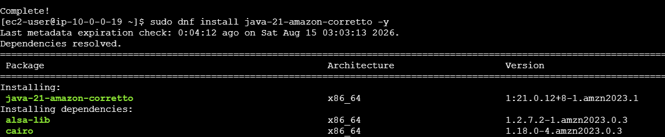
Check:
java -version

4. Create SonarQube user
sudo useradd -r -m -U -d /opt/sonarqube -s /bin/bash sonar

5. Download SonarQube
Download the desired SonarQube Linux ZIP into /opt, then:
cd /opt
sudo unzip sonarqube-*.zip
sudo mv sonarqube-* sonarqube
sudo chown -R sonar:sonar /opt/sonarqube
Download SonarQube
Run:cd /opt
sudo wget https://binaries.sonarsource.com/Distribution/sonarqube/sonarqube-25.12.0.117093.zip

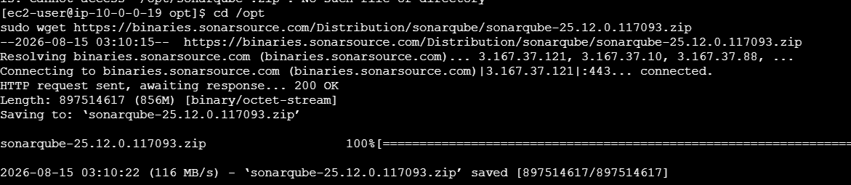
Then verify:
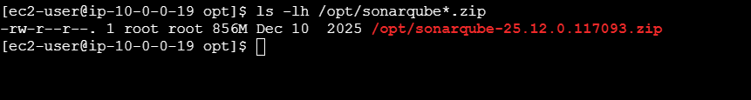
Extract : Only after the ZIP is present:
sudo unzip sonarqube-25.12.0.117093.zip
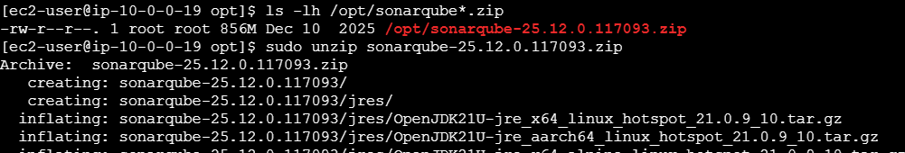
Then:
sudo mv /opt/sonarqube-25.12.0.117093 /opt/sonarqube

Step 3 — Ownership
sudo chown -R sonar:sonar /opt/sonarqube

ls -ld /opt/sonarqube
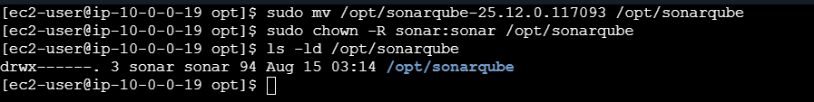

Find Java 21 path
Run:
readlink -f $(which java)
You should get something like:
/usr/lib/jvm/java-21-amazon-corretto.x86_64/bin/java
Set JAVA_HOME
Run:
sudo tee /etc/profile.d/java.sh > /dev/null <<'EOF'
export JAVA_HOME=/usr/lib/jvm/java-21-amazon-corretto.x86_64
export PATH=$JAVA_HOME/bin:$PATH
EOF
Load it:
source /etc/profile.d/java.sh
Step 3 — Verify
echo $JAVA_HOME
java -version
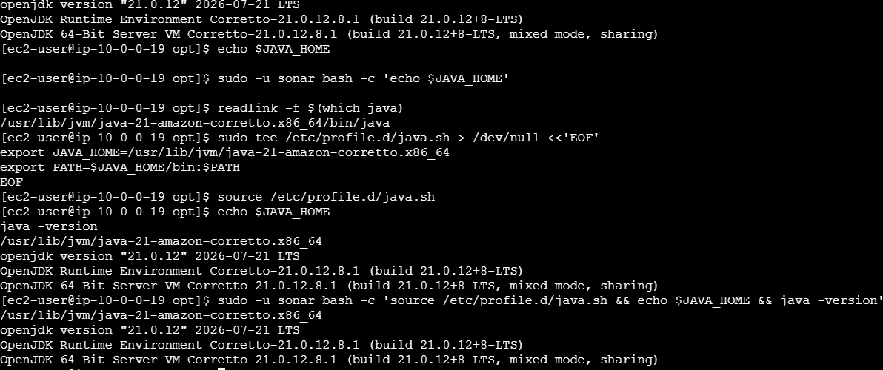

Verify for sonar user
sudo -u sonar bash -c 'source /etc/profile.d/java.sh && echo $JAVA_HOME && java -version' 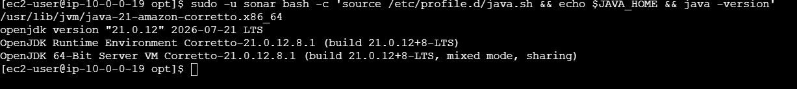

SonarQube directory structure
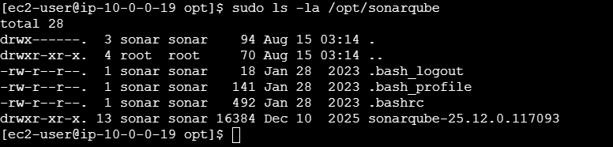

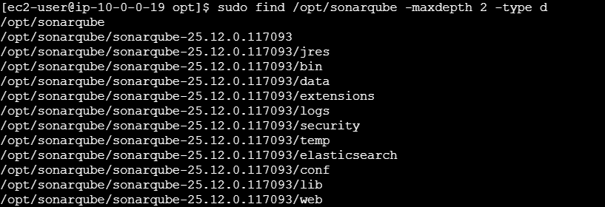
Step 5 — Start SonarQube
sudo -u sonar /opt/sonarqube/bin/linux-x86-64/sonar.sh start
sudo -u sonar /opt/sonarqube/bin/linux-x86-64/sonar.sh status
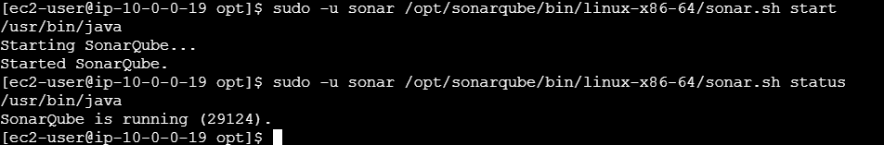

7. Open port 9000
SonarQube EC2 Security Group:
TCP 9000 → Jenkins Security Group
8. Test from Jenkins
Find SonarQube private IP:
hostname -I
On Jenkins:
curl -I http://<SONAR_PRIVATE_IP>:9000
9. Open SonarQube
http://3.235.17.108:9000
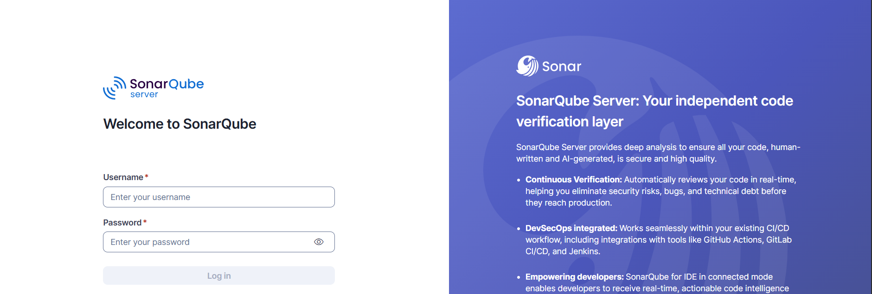
10. Create token
SonarQube → My Account → Security → Generate Token
Name: jenkins-hiring-app
Copy the token. 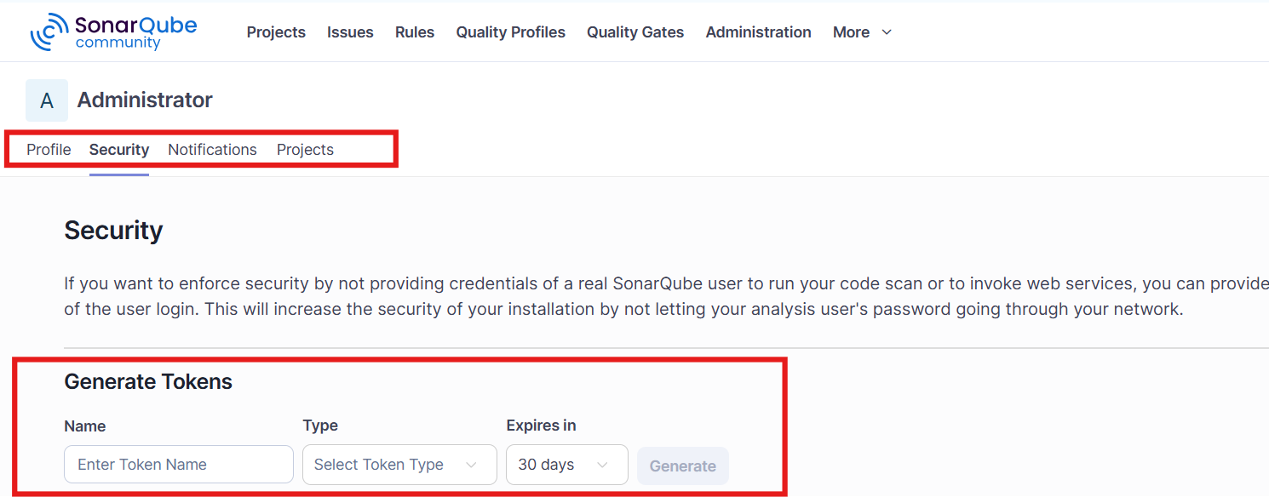
Next: Configure this SonarQube server and token in Jenkins → then add Stage 2.

Stage3: Slack Integration to send the alerts to slack.
Stage 3 — New Slack Workspace
- Open Slack → Create a new workspace.
- Create workspace: DevOps
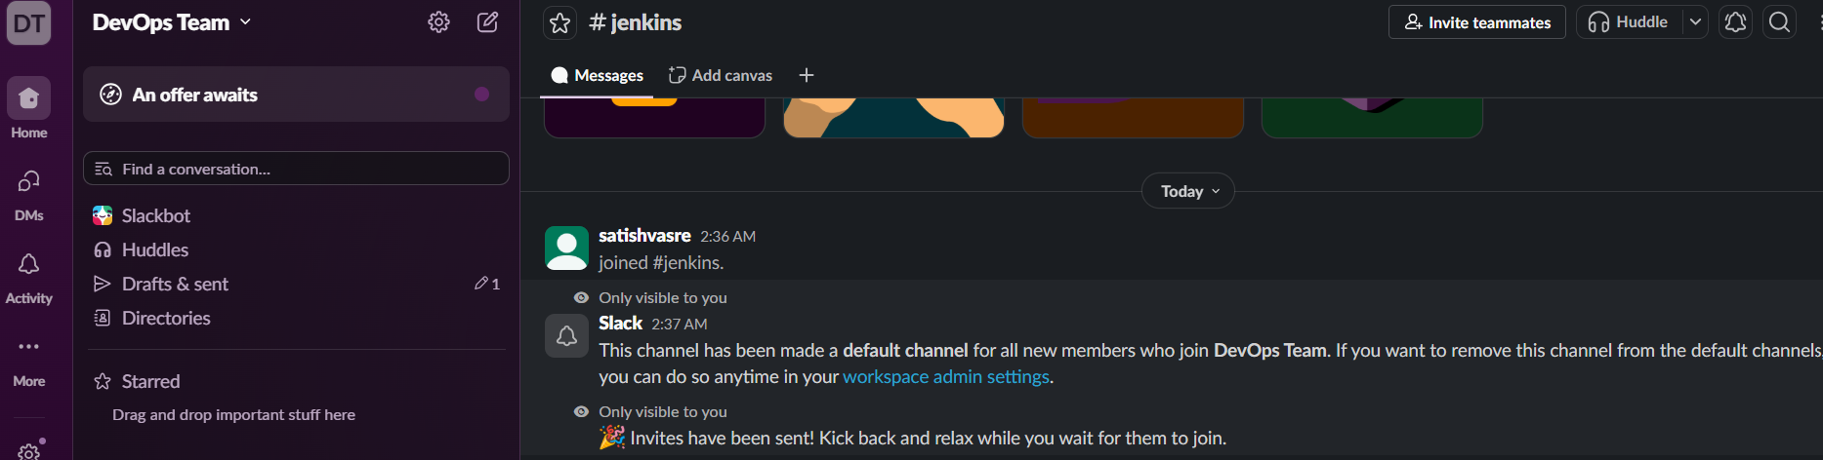

- Create channel: #proj-hiring-app
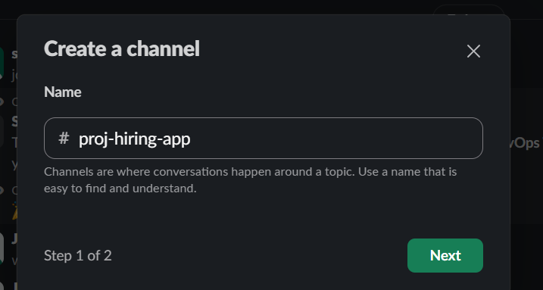
- Open Slack API Apps.
- Create New App → From scratch.
- App name: hiring app-Jenkins
- Select workspace: DevOps-team
- Incoming Webhooks → ON.
- Add New Webhook to Workspace → #jenkins → Allow.
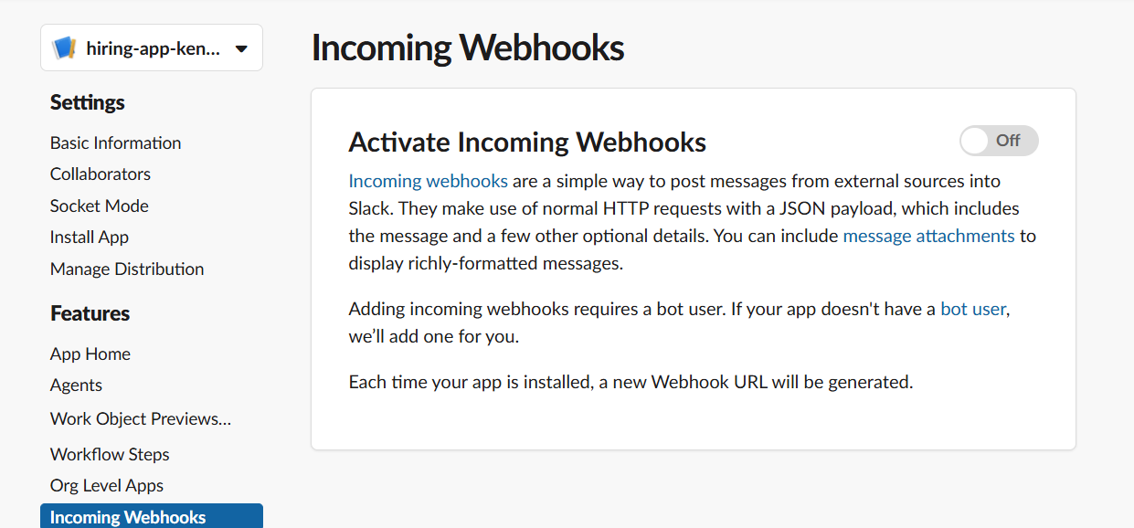
- Copy the webhook URL and keep it secret.
- In Jenkins: Manage Jenkins → Plugins → install Slack Notification.
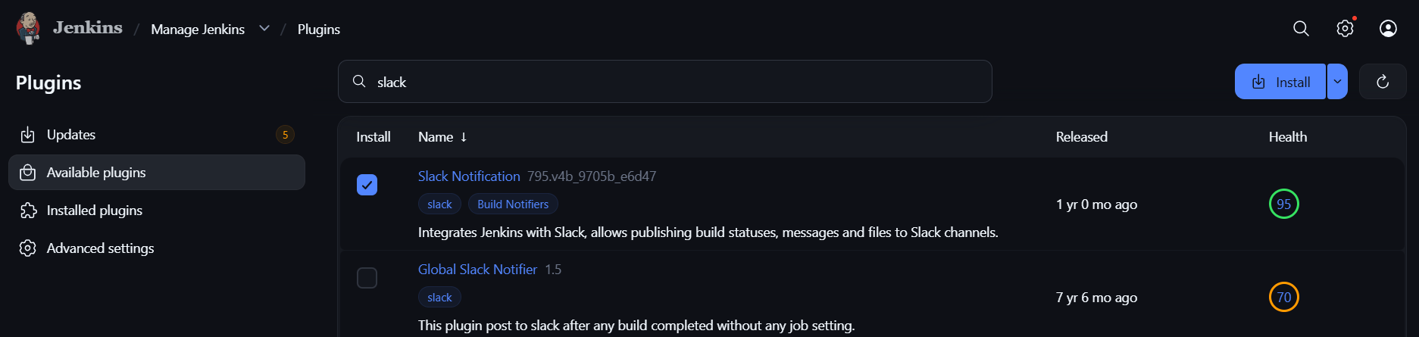
- Manage Jenkins → System → Slack Notifications → configure Slack → Test Connection.
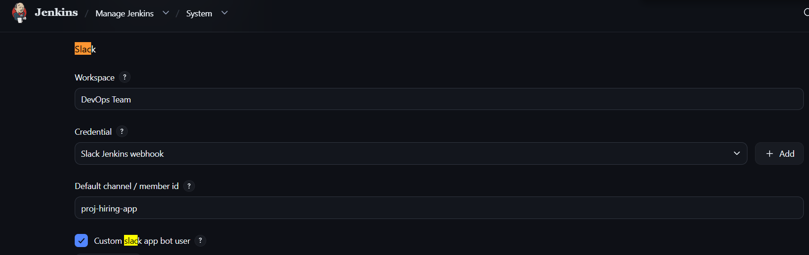
- Stage 3 — Slack in Freestyle
- Go to: Jenkins → your job → Configure
- Scroll to the bottom.
- 1. Find Post-build Actions
- Click:
- Add post-build action
- Look for:
- Slack Notifications
- Select it.
- 2. Configure
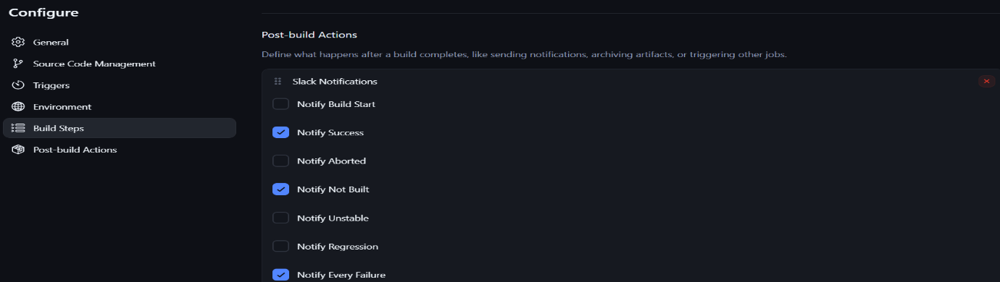
- You should see options such as:

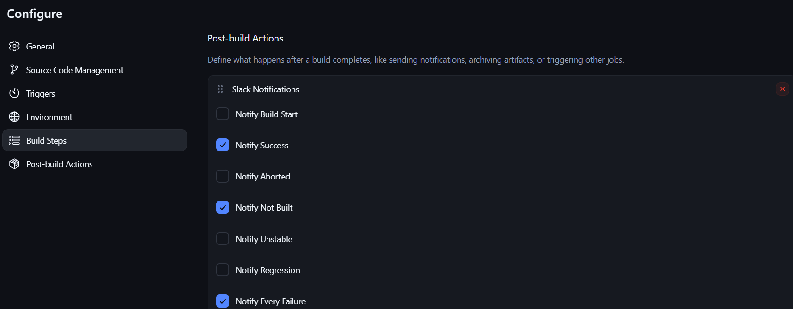

Jenkins → SonarQube — Short Steps
- Install plugin
  - Jenkins → Manage Jenkins → Plugins
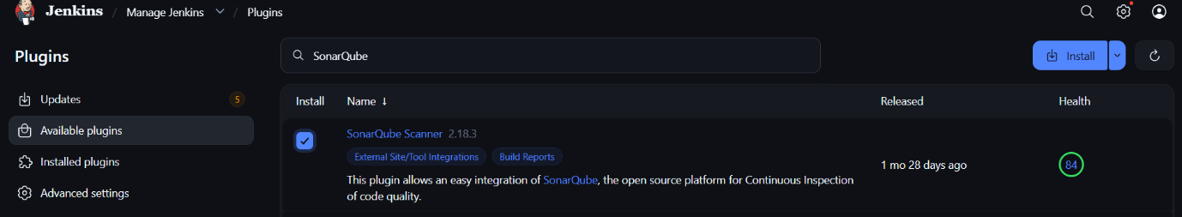
  - Install SonarQube Scanner for Jenkins

- Create SonarQube token
  - SonarQube → My Account → Security → Generate Token
  - Copy token.
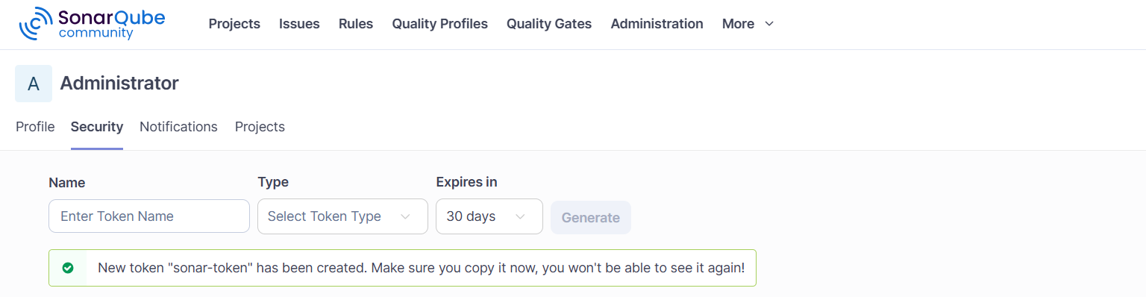

- Add token to Jenkins
  - Jenkins → Manage Jenkins → Credentials
  - Add:
Kind: Secret text
Secret: SonarQube token
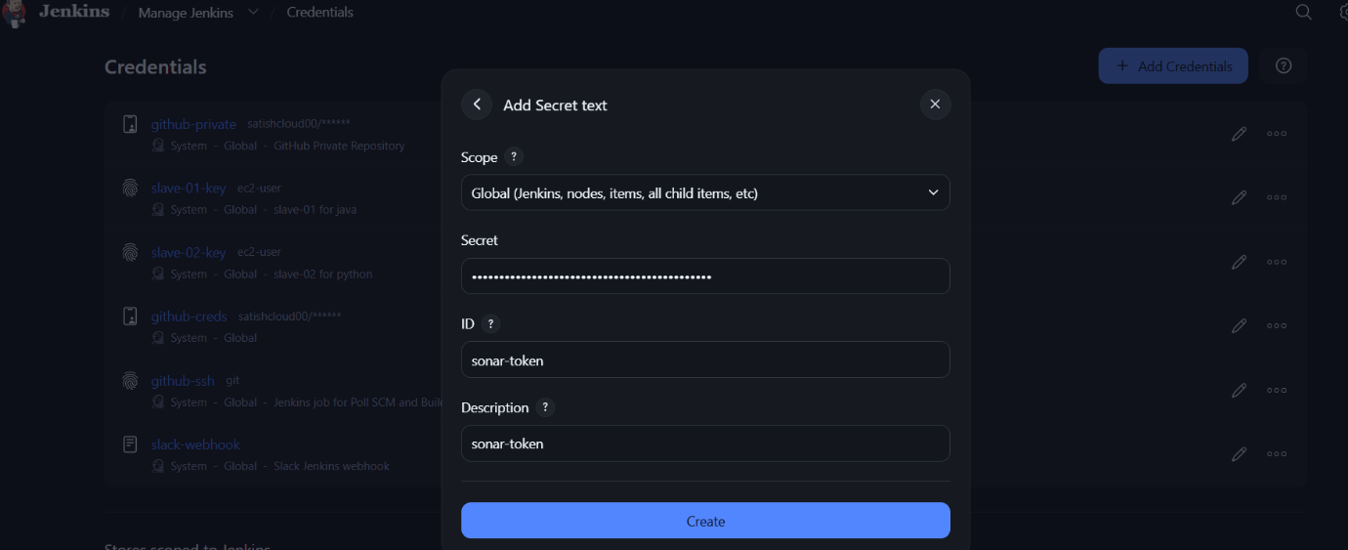
ID: sonar-token

- Configure SonarQube
  - Jenkins → Manage Jenkins → System
  - SonarQube servers → Add
- Name: SonarQube-New
- Server URL: http://10.0.0.19:9000
- Authentication Token: sonar-token
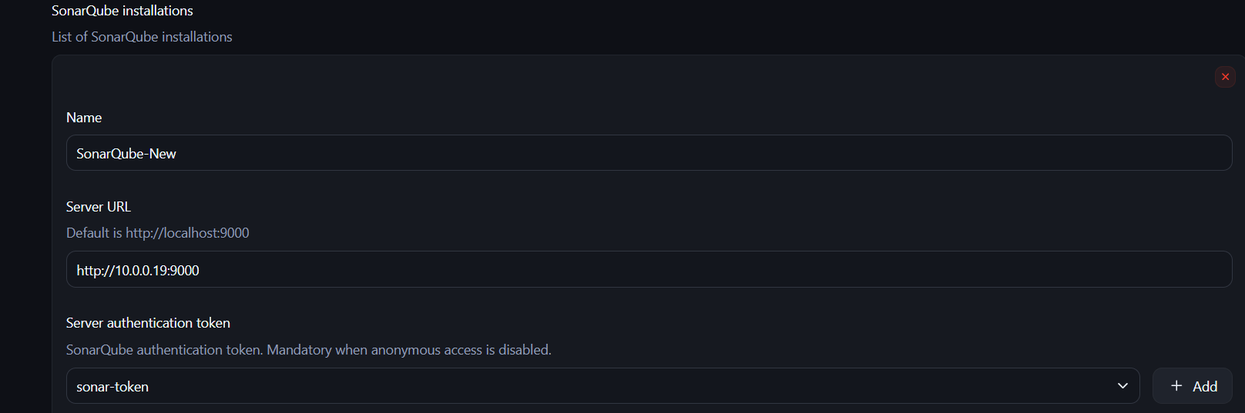
- Configure Scanner
  - Jenkins → Manage Jenkins → Tools
  - SonarQube Scanner → Add SonarScanner
  - Enable Install automatically
- Add to your Freestyle job
  - Job → Configure → Build Steps
  - Add Execute SonarQube Scanner
  - For Maven project, use:
mvn clean verify sonar:sonar
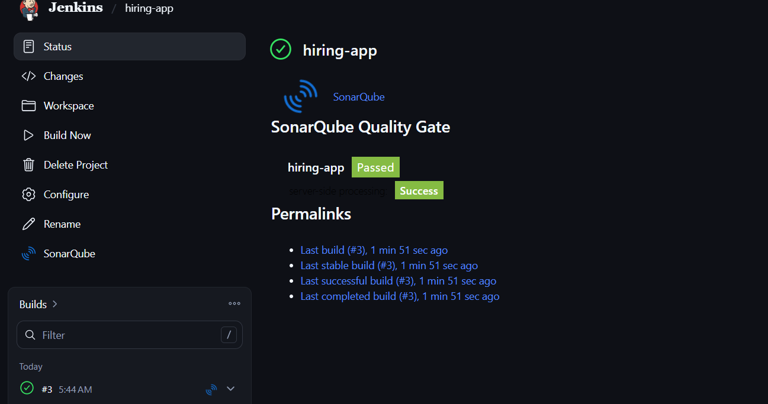
- Save → Build Now

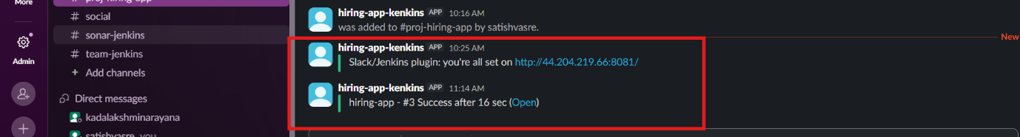
Then check SonarQube → Projects for hiring-app.

